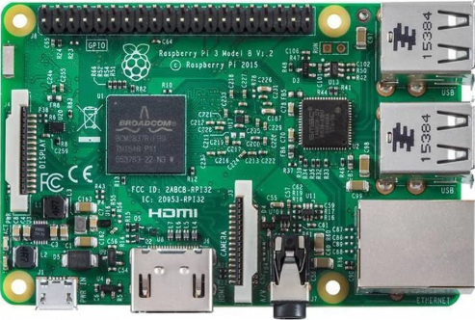

Leader

07

08

07

07

09

10

09

09

10

10

Followers

